# 

Contents

I. Delivery: 2

II. Domain – Education: 4

III. Agile 4

A. Spotify Agile Model 4

# Delivery:

## Key Delivery focus areas

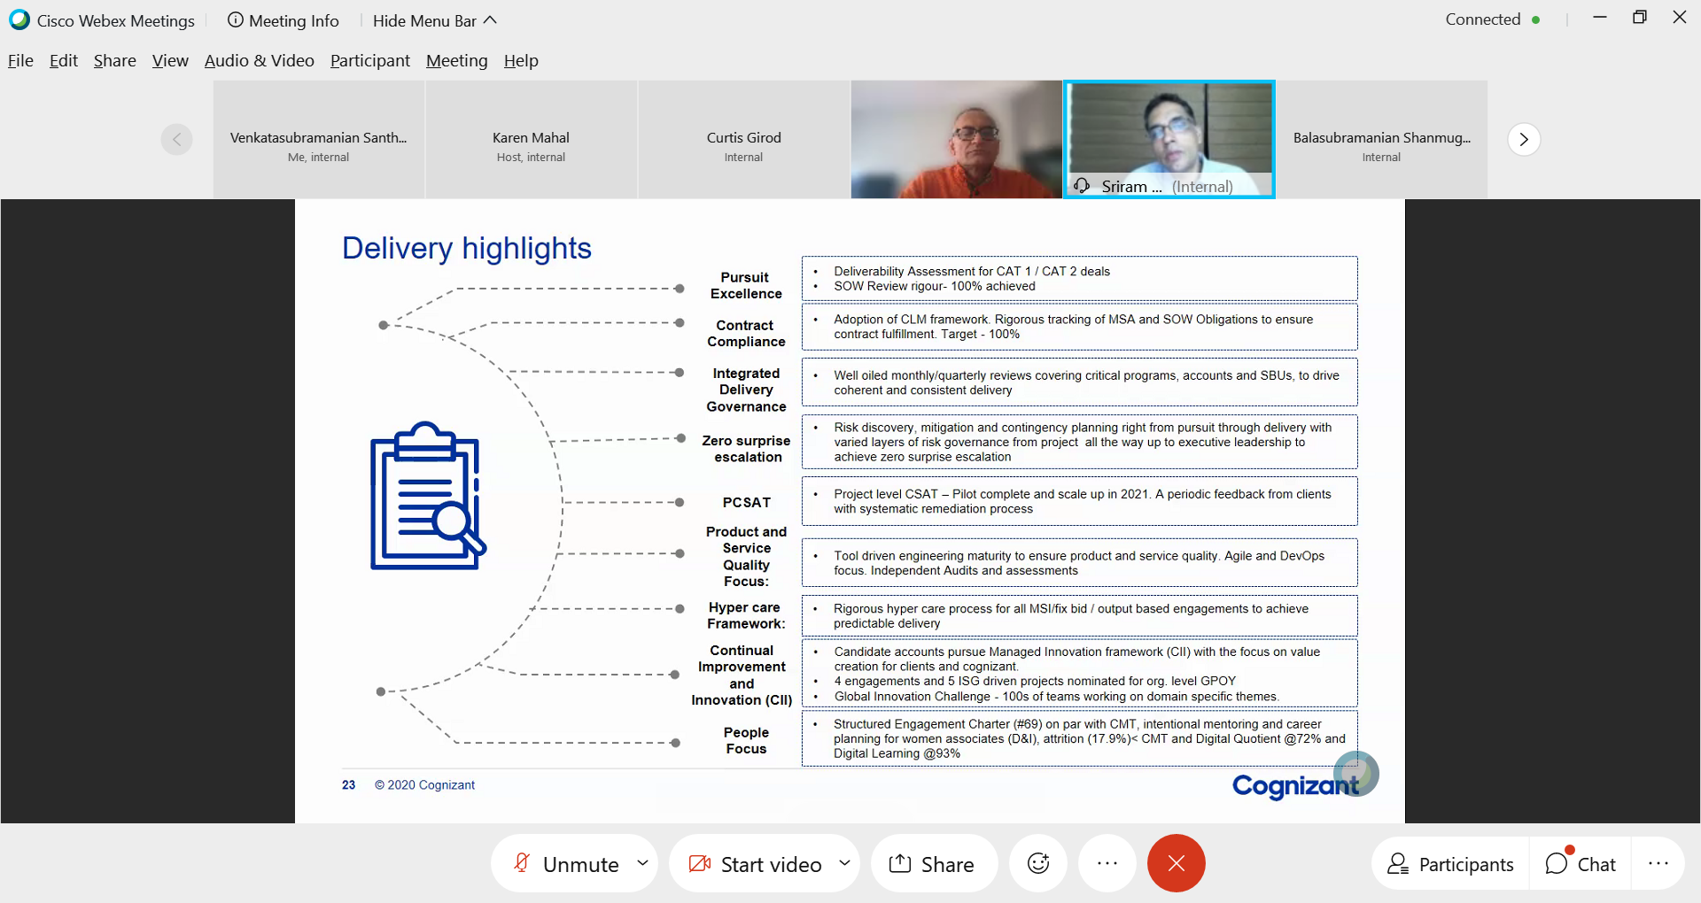

## Delivery Dashboard

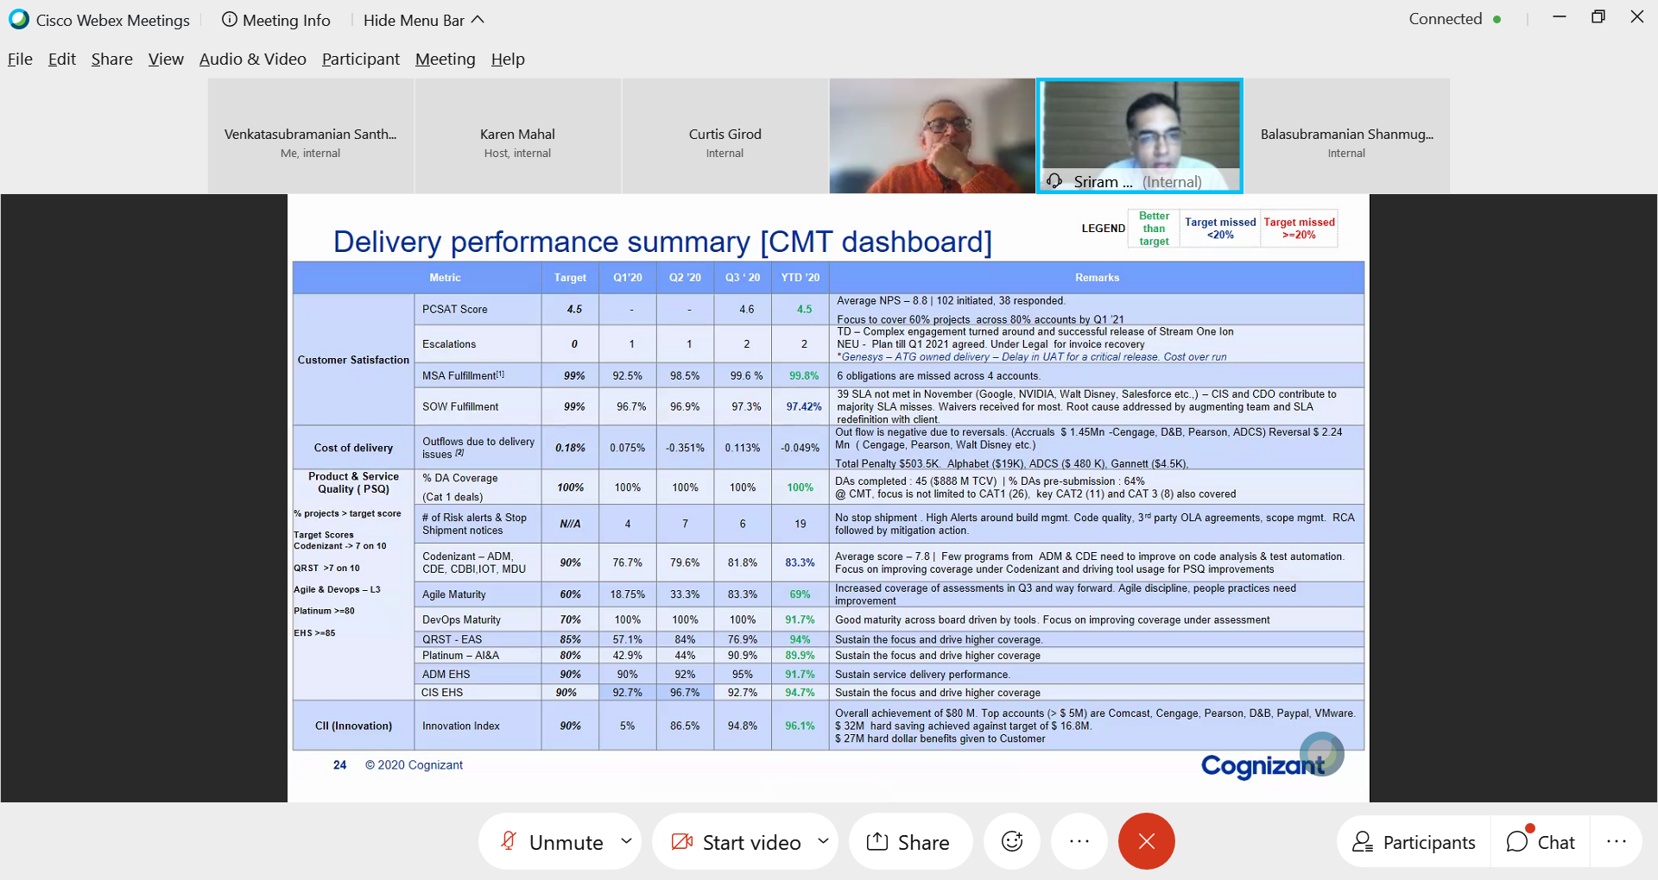

## Operation Rigor

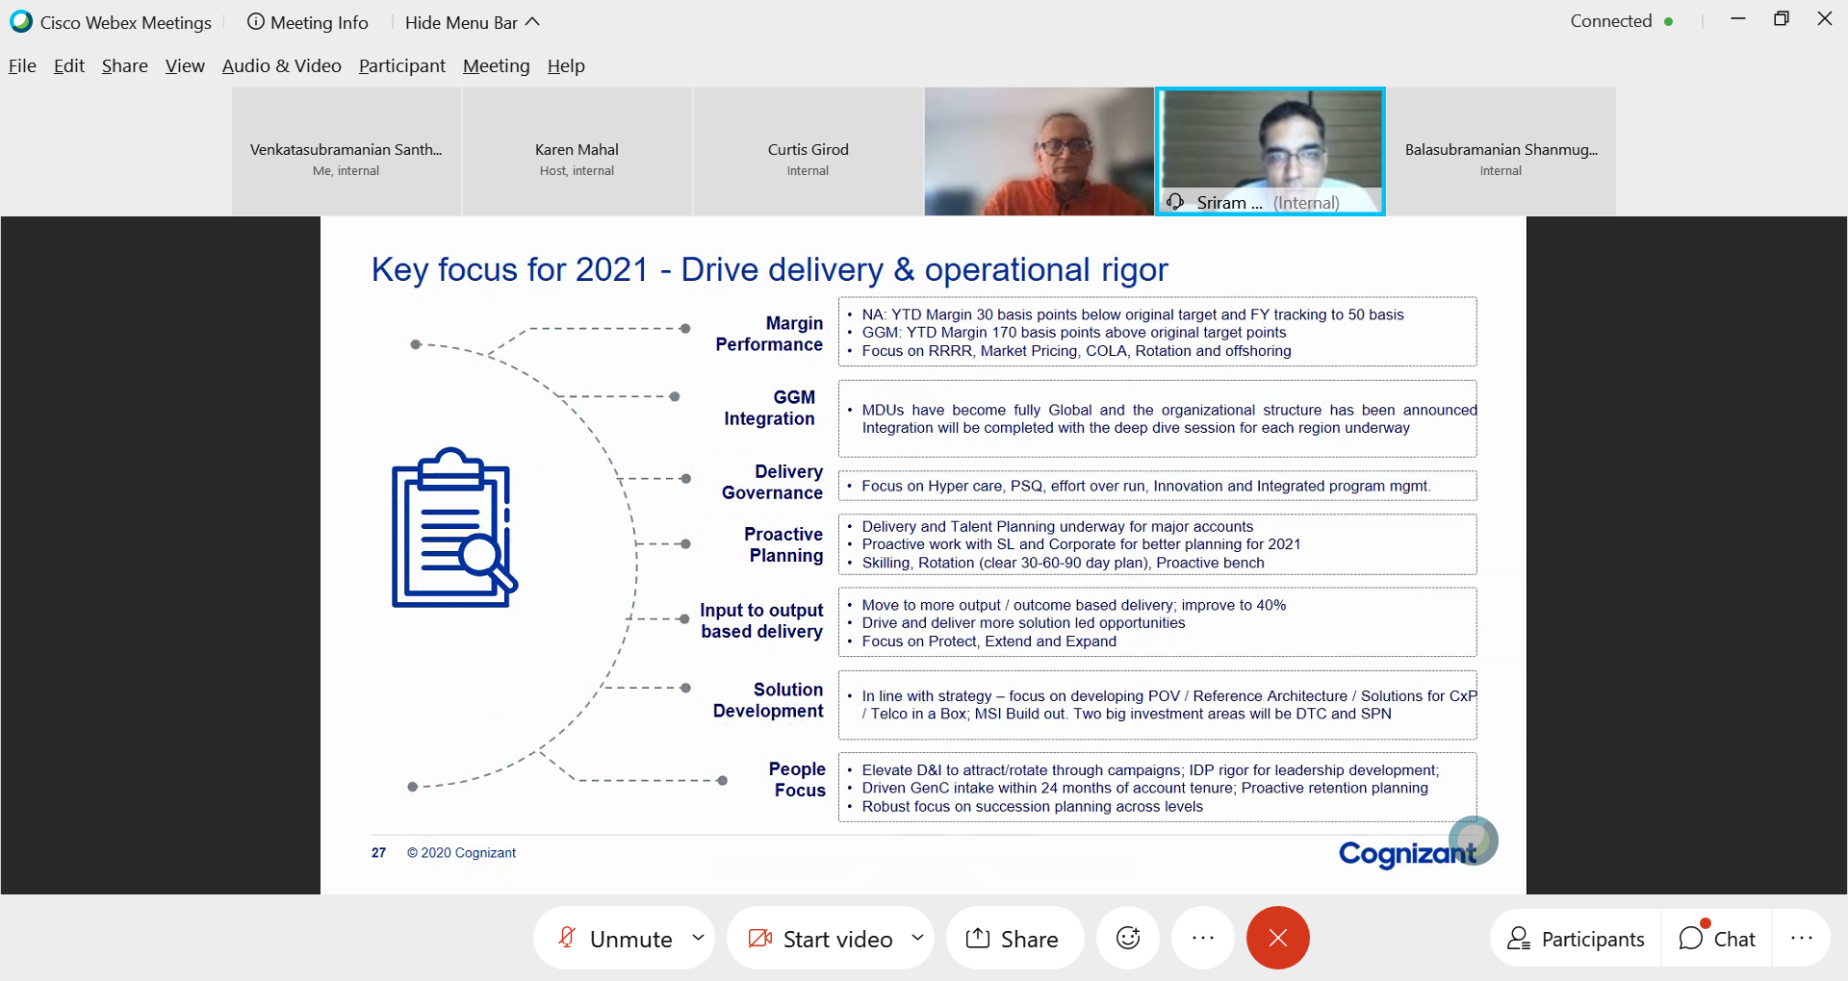

## 2021 Focus Areas

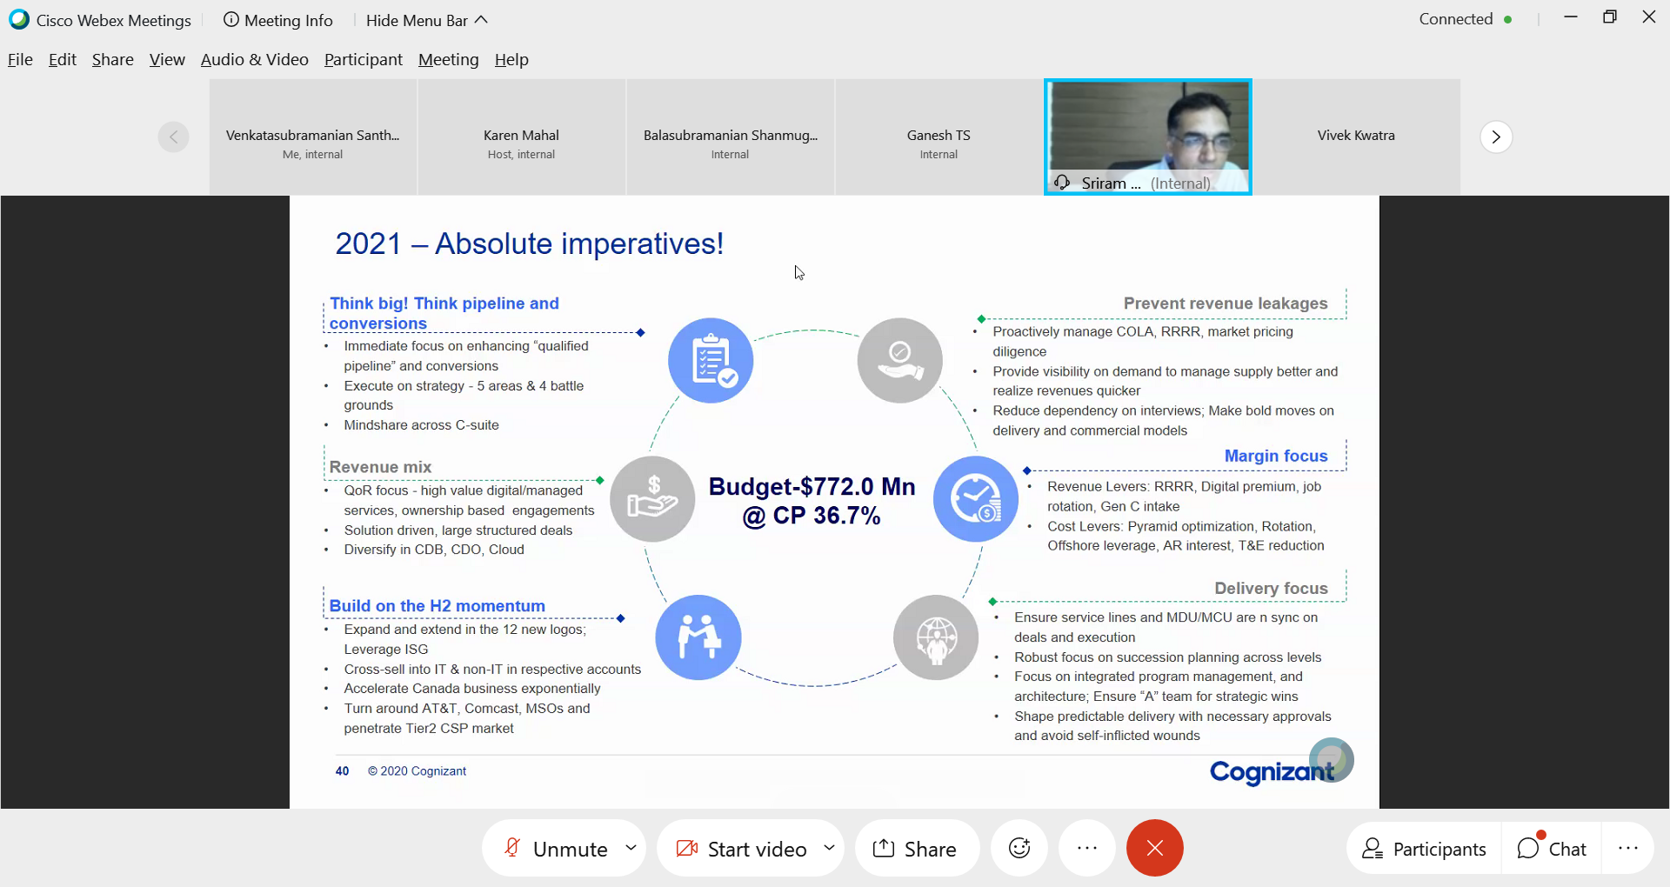

# Domain – Education:

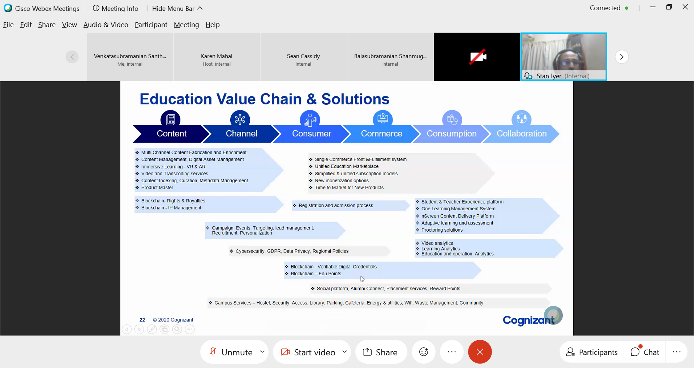

# Agile

## Scrum vs Kanban

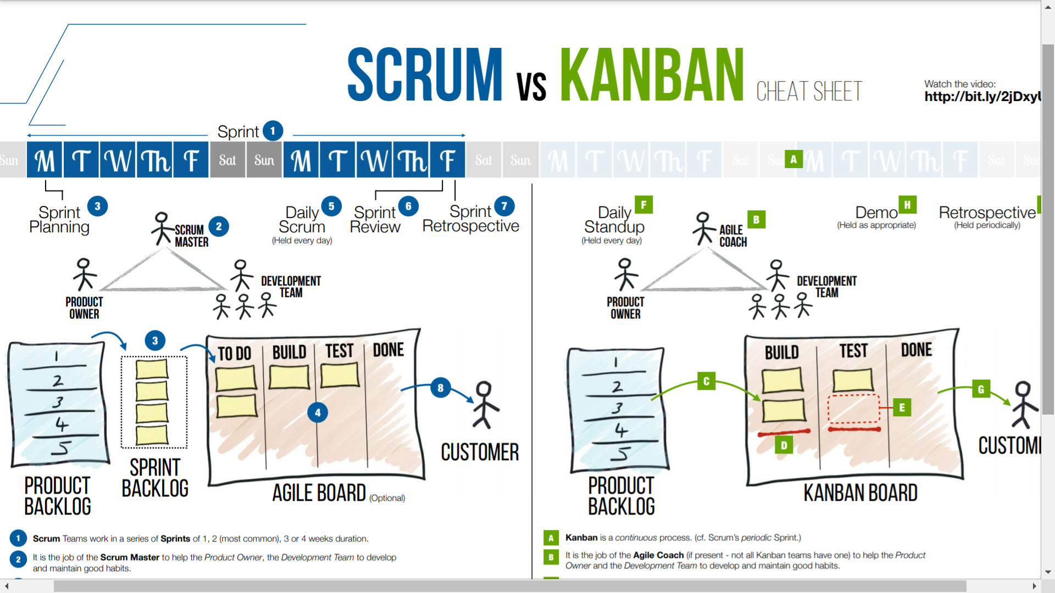

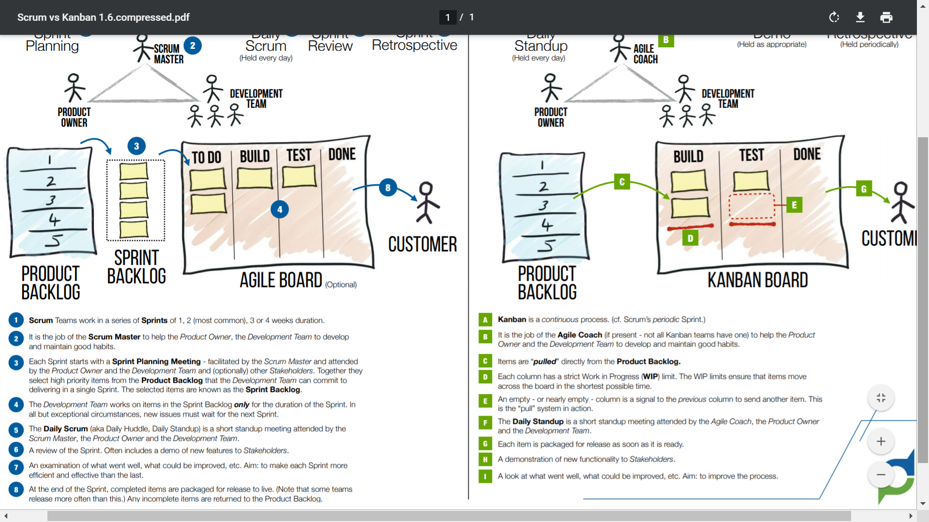

## Spotify Agile Model

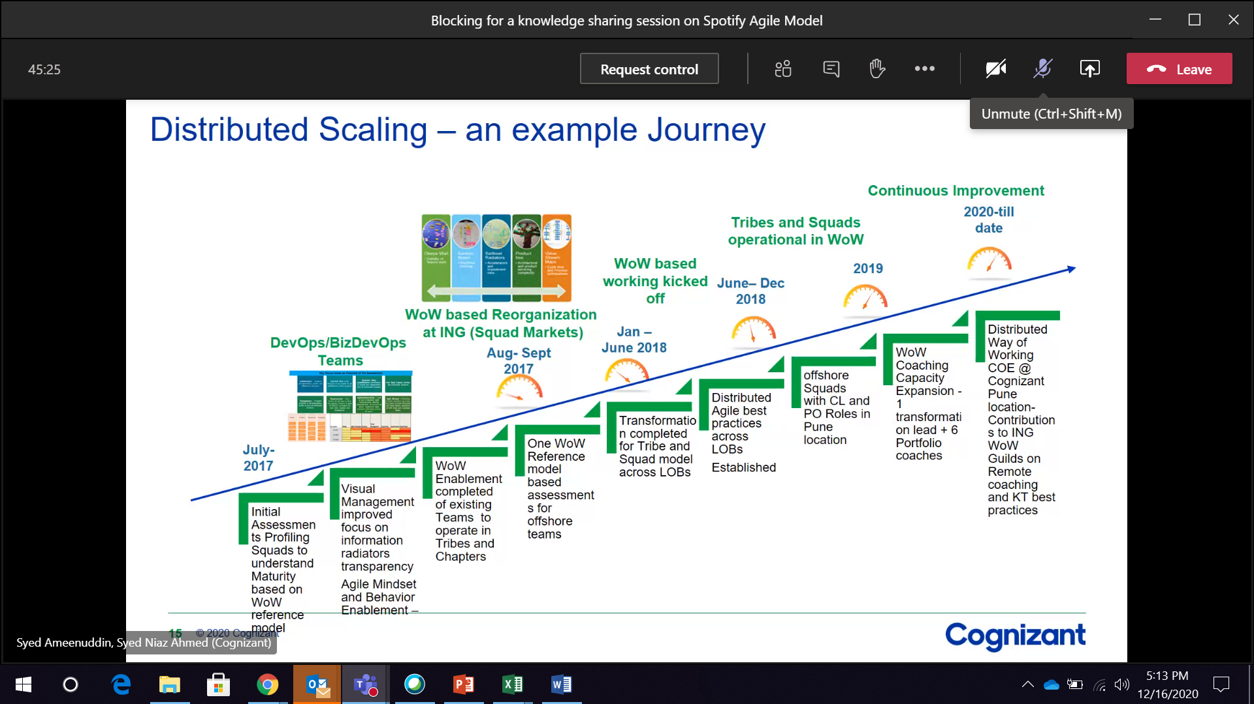



# Cloud

## AWS Basics

### Typical on-prem Tech Architecture:

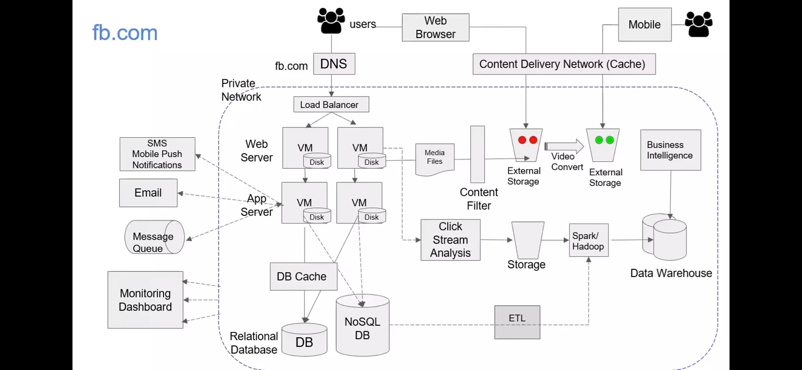

### Typical AWS Tech Architecture:

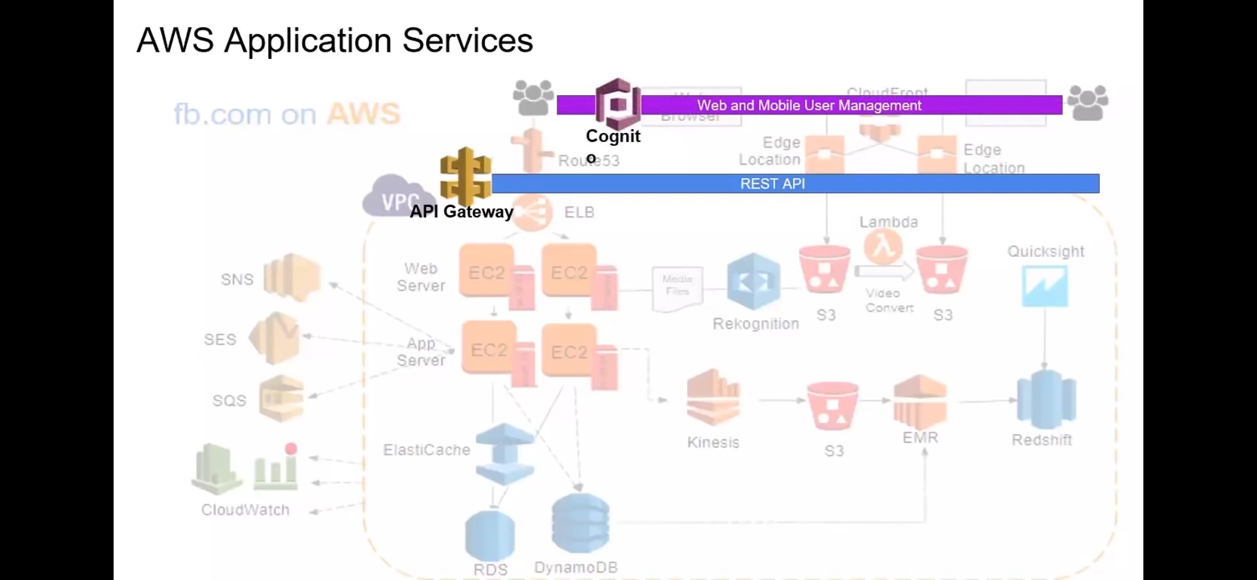

## Cognizant Cloud Assessment Framework

